Use Python code in TypeScript
To invoke the following task, run the following command in terminal:
npm install python-shell
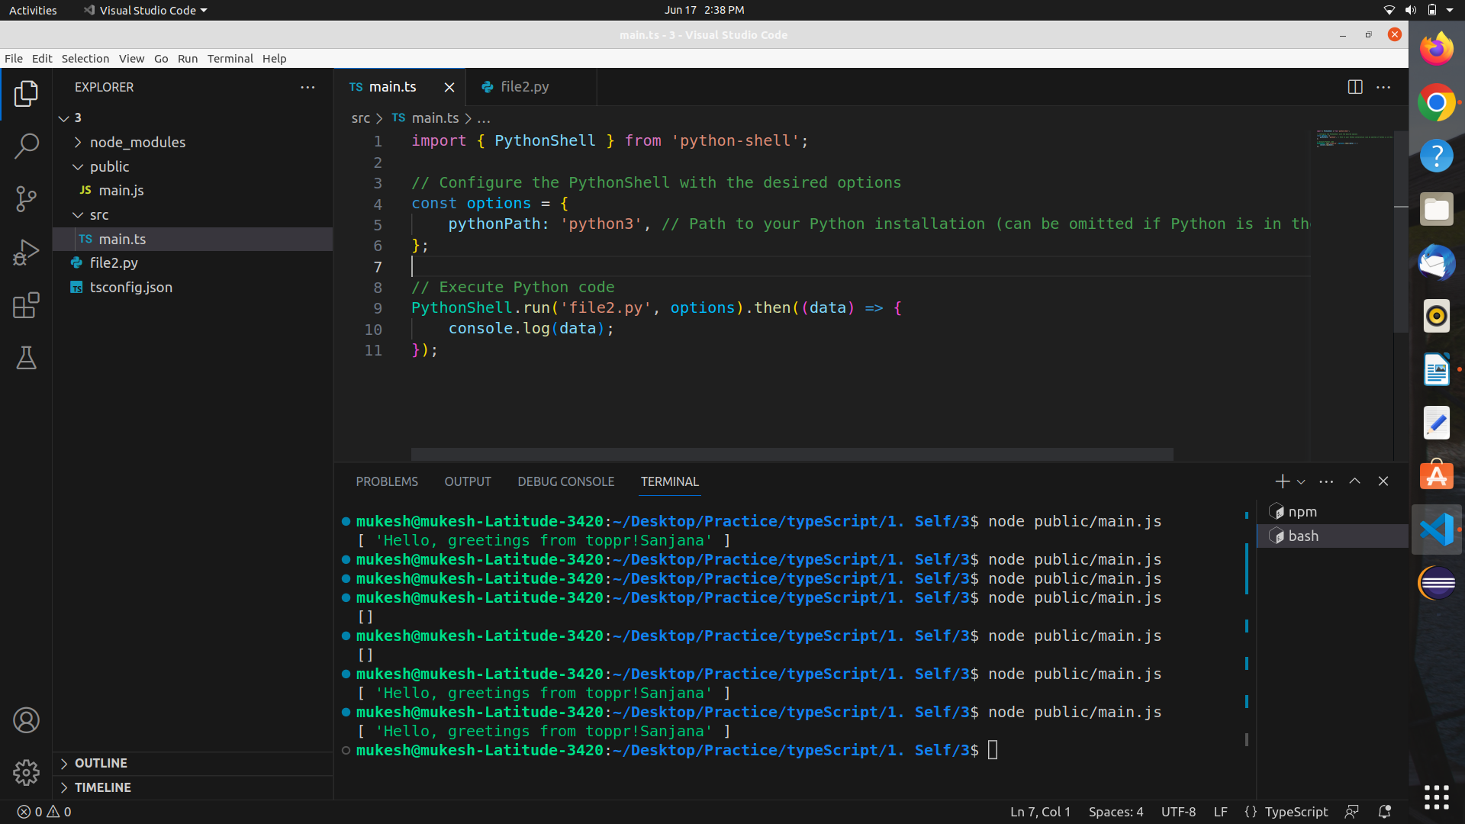

Example 1:

main.ts
import { PythonShell } from 'python-shell';

// Configure the PythonShell with the desired options
const options = {
pythonPath: 'python3', // Path to your Python installation (can be omitted if Python is in the system path)
};

// Execute Python code
PythonShell.run('file2.py', options).then((data) => {
console.log(data);
});

file2.py
def greet(name):
print("Hello, greetings from toppr!" + name);
name = "Sanjana";
greet(name);

Example 2:
To invoke the following task, run the following command in terminal:
npm install child_process

main.ts
import { execSync } from 'child_process';
// Define the path to the Python file
const pythonFilePath = 'file2.py';
// Execute the Python file and capture the output
const output = execSync(`python3 ${pythonFilePath}`).toString();
console.log(output);

file2.py
def greet(name):
print("Hello, greetings from toppr!" + name);
name = "Sanjana";
greet(name);

Example 3:

file2.py
import sys
def multiply_numbers(a, b):
return a * b
# Retrieve arguments from command line
a = int(sys.argv[1])
b = int(sys.argv[2])
# Call the multiply_numbers method and print the result
result = multiply_numbers(a, b)
print(result)

main.ts
import { execSync } from 'child_process';
// Define the command-line arguments to be passed to the Python method
const a = 60;
const b = 4;
// Execute the Python code and capture the output
const output = execSync(`python3 file2.py ${a} ${b}`).toString();
const result = parseInt(output.trim());
console.log(result); // Output: 240

